
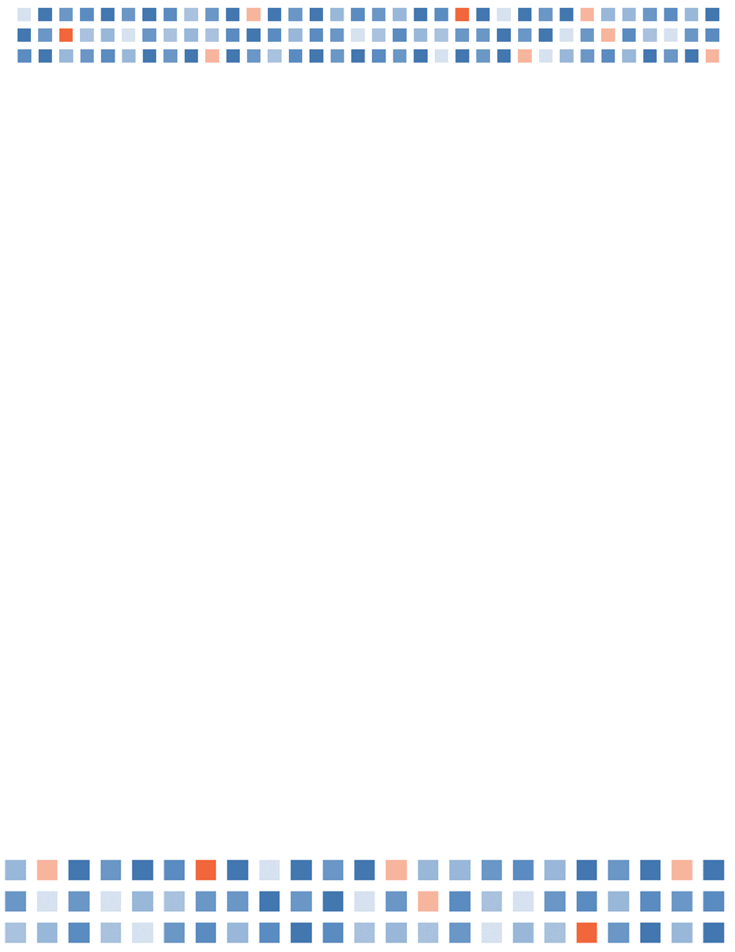

Society of Clinical Child and Adolescent Psychology
American Psychological Association, Division 53

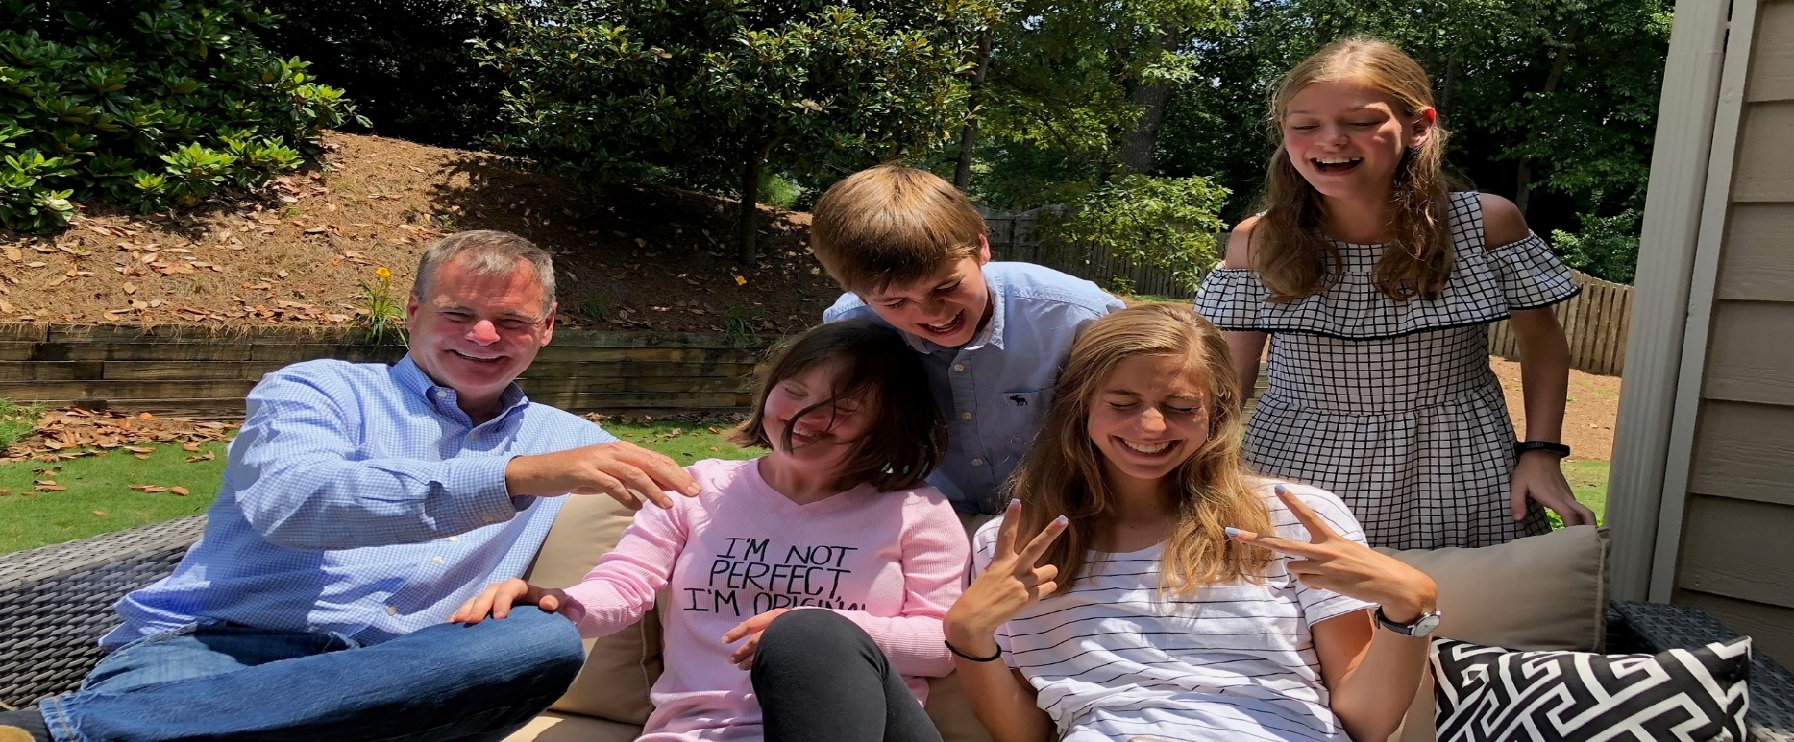
APA Convention Brochure
San Francisco, CA
August 9 – 12, 2018
Advocating for the Mental Health
Needs of Children and Adolescents

Table of Contents

Welcome to San Francisco 3
SCCAP Division 53 4
Board of Directors 6
Standing Committees 7
Liaisons & SIGs 8
SCCAP Programs: THURSDAY 9
SCCAP Programs: FRIDAY 10
SCCAP Programs: SATURDAY 11
SCCAP Programs: SUNDAY 12
Suite Programs Thursday Aug 9 13
Suite Programs Friday Aug 10 14
Suite Programs Saturday Aug 11 15
Professional Development Series 16
Unlimited CE Credit at APA 2018 17
Student Mentorship Flier 18
Join Us! 19
Celebrating our 2018 Award Winners 20
Thank You to Our Award Reviewers 21

Welcome to San Francisco

Dear Attendee:
Welcome to the APA 2018 Convention in San Francisco! We are delighted that you are here.
As your programming chairs, we are excited to welcome you to this year’s conference. As you’ll see in the next few pages, we have worked hard to create a program of research presentations designed to provide you with cutting edge research in the area of child and adolescent psychology.
Each symposium includes internationally known experts in research in the respective areas. We have presentations that cover topics across the gamut of child and adolescent psychology, including autism spectrum disorders, disruptive behavior disorders, depression and suicidal ideation and behavior, and much more. We have additional presentations on opening psychological science for everyone and funding opportunities from the National Institutes of Health.
We have three keynote presentations that we would love for you to attend and bring your colleagues: (1) Tom Insel, MD “Smartphones Are a Problem: Can They Be a Solution?,” (2) Sally Ozonoff, PhD, “Advances in Early Detection of Autism Spectrum Disorder,” and (3) Carolyn Webster Stratton, PhD, “37 Incredible Years: The Development and Innovation of the Incredible Years Program – Where to Go from Here?”.
Please make sure to check out the schedule of programming in the hospitality suite which includes opportunities for networking and obtaining mentorship.
Our hope is that you will have many opportunities to learn, network, and enjoy yourself! Be sure to follow us on Twitter:(@_SCCAP). We will be posting reminders of upcoming talks. If you use social media, be sure to tag us with #SCCAPatAPA #APA2018.
Again, welcome and please enjoy yourself!

Sincerely,
Adam Miller, PhD and Meghan Miller, PhD
Programming Co-Chairs

SCCAP Division 53

Mission
The purpose of SCCAP is to encourage the development and advancement of clinical child and adolescent psychology through integration of its scientific and professional aspects. SCCAP promotes scientific inquiry, training, professional practice, and public policy in clinical child and adolescent psychology as a means of improving the welfare and mental health of children, youth, and families in the context of a diverse society. In the service of these goals, SCCAP promotes the general objectives of the American Psychological Association.

Vision
From its inception, the Society of Clinical Child and Adolescent Psychology (SCCAP), APA Division 53, has been committed to advancing the clinical knowledge base and services provided to children and their families.
SCCAP continues this important agenda through policy work as it relates to child and adolescent mental health, through shaping and building the scientific practice, and through conferences designed to bring cutting-edge clinical research to frontline practitioners.
SCCAP’s creation, growth, and advancement continue to demonstrate a commitment to both science and practice. Through the membership’s expertise, energy, and commitment, and the financial and journal resources, SCCAP is in a unique position to influence the research and clinical practice of child and adolescent psychology now and in the future.
SCCAP’s educational and scientific conferences strengthen efforts to advance the knowledge and skills of practitioners and researchers.
Thanks to your membership, SCCAP is able to work toward improvements in children’s mental health care services at local and national levels. It also offers advocacy in support of mental health careers and training. Because of SCCAP’s continued growth, which is directly related to representation on APA’s Council of Representatives, SCCAP’s membership has a strong voice on APA task forces and committees, as well as participates in ongoing discussions on clinical child specialization and accreditation.

Contact us at:
Our Websites: SCCAP53.org
EffectiveChildTherapy.org
Email: SCCAPDiv53@gmail.com
Phone: 470-304-2468

SCCAP Division 53

Member Benefits
Join us! Together we can advance the cause of promoting healthy mental health for children and adolescents. Visit SCCAP53.org for complete membership information.
Member Discounts — Members receive discounted registration at Miami International Child and Adolescent Mental Health Conference and the National Conference in Clinical Child and Adolescent Psychology. Taylor and Francis also offers discounts on their publications to SCCAP members. SCCAP Webinar rates are reduced for members.
Grants and Awards — SCCAP invests in its members by offering many award and grant opportunities in research and practice.
Our Journals — Journal of Clinical Child and Adolescent Psychology is a leading child psychopathology and treatment journal and Evidence-Based Practice in Child and Adolescent Mental Health is an evidenced-based practice-oriented journal.
Forum Discussions — Join our network of thousands of psychologists and students through our online, members-only community! This exclusive forum allows for participating in scientific and professional discussions, organizing messages by topics, and reviewing past messages. It is a more permanent, organized, and interactive version of the SCCAP Listserv.
Our Newsletter — InBalance offers topical features, news of interest, and important policy related information.
Listservs — A members-only listserv provides opportunity for peer consultations, resource requests discussion forum for practice, scientific and professional topics, job openings and APA updates. Students may join the student only listserv.
Professional Consultations and Discussions — A members-only listserv provides opportunities for professional peer consultations and for scientific and professional topics. Students may also join a Student Only listserv.
Convention Activities — We sponsor activities at the APA Convention and regional conferences, including symposia, workshops, poster sessions, and social hour. Learn, exchange information, and stay abreast of current clinical and research topics.
Continuing Education and Professional Development — CE credits can be obtained at the APA annual convention and through the SCCAP webinar series. The online Career Center is a repository for members looking for internship and professional career openings. Members have access to thousands of journals, psychological and medical textbooks, government and open databases, prescreened peer-reviewed articles, and online databases.
Task Forces and Special Interest Groups — Help us by joining the efforts to advance the issues around children and adolescent mental health. Instructions for joining or starting a SIG are online.
Focus on Students — SCCAP invests in the future by supporting it student members. For easier access students receive free memberships and webinars, manage the Student Advisory Committee and serve on all SCCAP committees, and mentorship programs

Advocacy for Children’s Mental Health — Perhaps most importantly, Division 53’s strength and size offer a crucial opportunity for advocacy. Thanks to your membership, SCCAP is able to work towards the improvement of children’s mental health care services at local and national levels and offer advocacy to support mental health careers and training.

Board of Directors

Officers
President (2018) Steve Lee, PhD
President-elect (2018) Eric Youngstrom, PhD
Past President (2018) Mitchell Prinstein, PhD, ABPP
Secretary (2013-2018) Jonathan Comer, PhD
Treasurer (2017-2019) David Langer, PhD, ABPP

Executive Committee
APA Council Representative (2014-2019) Mary A. Fristad, PhD, ABPP
APA Council Representative (2016-2021) Timothy A. Cavell, PhD
Member at Large (2014-2019) Amanda Jensen-Doss, PhD
Member at Large (2010-2018) Yolanda Jackson, PhD, ABPP
Member at Large (2018-2020) Tara Peris, PhD

Board Members-Non-Voting
JCCAP Journal Editor (2017-2021) Andres De Los Reyes, PhD
EPCAMPH Journal Editor (2016-2020) Anne Marie Albano, PhD
Web Editor (2017-19) Stephon Proctor, PhD, ABPP
Newsletter Editor (2018-2020) Jennifer Hughes, PhD, MPH
APA Convention Program Chair (2018) Adam Miller, PhD
APA Convention Program Chair (2019) Meghan Miller, PhD
Student Representative (2017-2018) Leigh Spivey, M.S.
Student Representative (2018-2019) Elizabeth Moroney, M.A.
Listserv Manager (2018-2020) Heather MacPherson, PhD
Communications Committee (2017-2019) Brian Chu, PhD
Diversity Committee (2017-2019) Erlanger Turner, PhD
Science Committee (2017-2019) Jill Ehreneich-May, PhD

Standing Committees

Fellows Committee
Steven Meyers, PhD, Chair
Mary Ann McCabe, PhD, ABPP
Kathy Grant, PhD

Awards Committee
Amanda Jensen-Doss, PhD, Chair
Yo Jackson, PhD, ABPP
Adam Lewin, PhD, ABPP
Tara Peris, PhD

Communications Committee
Brian Chu, PhD, Chair
Stephon Proctor, PhD, ABPP
Jennifer Hughes, PhD
Heather MacPherson, PhD
Courtney Benjamin Wolk, PhD
Shannon Bennett, PhD
Kristin Hawley, PhD
Erum Nadeem, PhD
Mian-Li Ong, M.S.
Sara Ghassemzadeh

Diversity Committee
Erlanger A. Turner, PhD, Chair
Artuto Corrales, Psy.D.
Khiela J. Holmes, PhD
Erica D. Musser, PhD
Nuri Reyes, PhD
Katia Ceneguez, PhD
Alexandra Gil

Education and Standards Committee
Tara Peris, PhD, Chair
Sunhye Bai, PhD, MPH
Shawn C. T. Jones, PhD, MHS

Membership Committee
Yo Jackson, PhD, Chair
Christopher Cushing, PhD, ABPP
Stephanie Gusler, PhD
Josh Langberg, PhD
Angela Tunno, PhD
Michael Southam-Gerow, PhD

Practice Committee
Amanda Jensen-Doss, PhD, Chair
Brian Allen, Psy.D.
Kelly Champion, PhD, ABPP
Jarrod Leffler, PhD, L.P
Jean Mercer, PhD
Bradley White, PhD
Lucia Walsh, M.S.

Science Committee
Jill Ehrenreich-May, PhD, Chair
Dan Banger, Psy.D
Paula Fite, PhD
Eli Lebowitz, PhD
Vanesa Ringle, PhD
Amy Krain Roy, PhD
Andres Viana, PhD
Andrea Young Ryan, PhD

Student Advisory Committee
Leigh Spivey M.S. , Chair
Beth Moroney, M.A. , Co-Chair
Joseph De Luca, M.A.
Lucas Zullo, B.A.
Bridget Makol, M.S.
Kristin Wolf, MRC
Sheina Godovich, B.A.
Katie Stone, M.A

Liaisons & SIGs

Liaisons
Committee on Children, Youth and Families
Adam Lewin, PhD, ABPP
APA Interdivisional Coalition for Psychology in Schools and Education
George DuPaul, PhD
APA Committee on Early Career Psychologists
Chrissy Cammarata, PhD
Council of Specialties (2016-2018)
Michael C. Roberts PhD, ABPP
CAAPS
Mitchell Prinstein, PhD, ABPP
Steve Lee, PhD

Special Interest Groups
Emerging Adulthood
Thomas McMahon, PhD
Amanda Zayde, PhD
Gender Variance
Marco Hidalgo, PhD
Diane Chen, PhD
Society for Health Psychology - IPC
Joan Asarnow, PhD
Sunhye Bai, PhD
Michelle Rozenman, PhD

SCCAP Programs: THURSDAY
Thursday, August 9 | Time | Room | CE  Credits | Co-Listing  Divisions
Symposium: The Neuroscience of ADHD From Early Childhood to Early Adulthood — Insights from Neuroimaging  Chair: Mark D. Rapport, Ph.D. | 8:00 AM  -  9:50 AM | Moscone Center  Room 214 | X | 12, 40, 54
Invited Address: Ask NIH — Program Officers from NIMH and NIDA Discuss Funding Priorities and More! | 10:00 AM  -  10:50 AM | Moscone Center  Room 3004 |  | 12, 20, 40,  56
Symposium: Innovations in Understanding Traumatic Stress in Youth  Chair: Jonathan S. Comer, Ph.D. | 11:00 AM  -  12:50 PM | Moscone Center  Rooms 305 & 309 | X | 54, 56
Invited Address: Smartphones are a problem: Can they be a solution? Tom Insel, M.D. | 1:00 PM  -  1:50 PM | Moscone Center  Room 2001 |  | 8, 12, 46
Suite Program: Networking for International Students-Make the most of APA  Eric Youngstrom, Ph.D. | 1:00 PM  -  2:30 PM | SCCAP Suite Marriott Marquis
Symposium: Youth Resilience, Depression, and Suicide in Schools — Prevention and Social Emotional Learning  Co-Chairs: Jennifer L. Hughes, Ph.D., MPH; Madhukar H. Trivedi, M.D. | 2:00 PM  -  3:50 PM | Moscone Center  Room 308 | X | 12, 16, 43
Collaborative Symposium: Psychological Perspectives on Rising Economic Inequality  Co-Chairs: Camelia E. Hostinar, Ph.D.; Johnna R. Swartz, Ph.D. | 2:00 PM  -  3:50 PM | Moscone Center  Room 158 | X | 7, 16, 38
Suite Program: Open House - ALL SCCAP Members welcome  Membership Committee | 3:00 PM  -  3:50 PM | SCCAP Suite Marriott Marquis
Suite Program: Student Advisory Committee: Mentorship Meet & Greet/Q&A, Leigh Spivey, M.S. | 4:00 PM  -  4:50 PM | SCCAP Suite Marriott Marquis
Suite Program: Student Advisory Committee Meeting, Leigh Spivey, M.S. | 5:00 PM  -  5:50 PM | SCCAP Suite Marriott Marquis
SCCAP Social Hour | 6:00 PM  -  6:50 PM | SCCAP Suite Marriott Marquis
Social Honoring Diane Willis | 6:00 PM – 8:00pm | Marriott Marquis Sierra Room J |  | 7, 16, 37, 53,CYF

SCCAP Programs: FRIDAY
Friday, August 10 | Time | Room | CE  Credits | Co-Listing  Divisions
Collaborative Symposium: The Adolescent Brain Cognitive Development (ABCD) Study — Overview, Emerging Data, and Opportunities  Chair: Sandra A. Brown, Ph.D. | 8:00 AM  -  9:50 AM | Moscone Center  Room 157 | X | 12, 28, 37,  40, 50
Symposium: Opening Up Psychology to Give it Away — Open Platforms to Bring Psychology to all People  Chair: Eric A. Youngstrom, Ph.D. | 8:00 AM  -  9:50 AM | Moscone Center  Room 159 | X | 1, 12, 17,  46, 52
Collaborative Symposium: Future Directions for Research in Child Maltreatment — Innovation in Science, Education, and Policy  Chair: Yo Jackson, Ph.D. | 10:00 AM  -  10:50 AM | Moscone Center  Room 157 | X | 37, 45, 54,  56
Suite Program: HGAPS Wiki Instruction/Editing  Eric Youngstrom, Ph.D. | 10:00 AM  -  10:50 AM | SCCAP Suite Marriott Marquis
Symposium: Innovations to Extend Best Practice Interventions for Children with Disruptive Behavior Disorder  Chair: David F. Curtis, Ph.D. | 10:00 AM  -  11:50 AM | Moscone Center  Room 151 | X | 12, 49, 54
Suite Program: HGAPS Wiki Instruction/Editing  Eric Youngstrom, Ph.D. | 11:00 AM  -  11:50 AM | SCCAP Suite Marriott Marquis
Suite Program: Council of Specialties Meeting  Michael Roberts,Ph.D. | 12:00 PM  -  12:50 PM | SCCAP Suite Marriott Marquis
Suite Program: Meet, Greet, and Get Published in Evidence-Based Practice in Child and Adolescent Mental Health! AnneMarie Albano,Ph.D. | 1:00 PM  -  2:50 PM | SCCAP Suite Marriott Marquis
Suite Program: Open House – ALL SCCAP Members welcome  Membership Committee | 3:00 PM  -  3:50 PM | SCCAP Suite Marriott Marquis
Cross Divisional Early Career Professional Social | 3:00 PM -3:50PM | Hilton San Francisco Union Square Hotel Golden Gate Room 8 |  | All Divisions
Symposium: You Harm Me, I Harm Myself — Peer Victimization, Self-Harm, and Suicidality in At-Risk Adolescents  Co-Chairs: Kirsty Lee, Ph.D.; Tracy Vaillancourt, Ph.D. | 4:00 PM  -  5:50 PM | Moscone Center  Room 206 | X | 12, 16, 29,  50, 54
Suite Program: SCCAP Gender Variance SIG Meeting  Marco Hidalgo, PhD Diane Chen PhD | 4:00 PM – 4:50pm | SCCAP Suite Marriott Marquis
Division 53 Board Meeting | 4:00 PM  -  5:50 PM | Marriott Marquis  Pacific Room B

SCCAP Programs: SATURDAY
Saturday, August 11 | Time | Room | CE  Credits | Co-Listing  Divisions
Symposium: Innovations for Integrating and Interpreting Multi-Informant Reports of Youth Psychopathology  Chair: Bridget A. Makol, M.S. | 8:00 AM  -  9:50 AM | Moscone Center  Room 214 | X | 12, 16, 33,  43
Poster Session: Child & Adolescent Psychopathology — Progress in Understanding the Role of Protective Factors, Parenting, and Intervention | 9:00 AM  -  9:50 AM | Moscone Center  Halls ABC
Suite Program: Multiculturalism and Media: Promoting Evidence-Based Children’s Mental Health, Cindy Graham, Ph.D, Diversity Committee | 9:00 AM  -  9:50 AM | SCCAP Suite Marriott Marquis
Poster Session: Latest Research on Mechanisms, Characterization, and Prediction of Psychopathology in Children & Adolescents | 10:00 AM  -  10:50 AM | Moscone Center  Halls ABC
Symposium: The Use of Telehealth Technology to Improve Research in Neurodevelopmental and Neurogenetic Disorders  Chair: Meagan R. Talbott, Ph.D. | 10:00 AM  -  10:50 AM | Moscone Center  Rooms 310 & 311 | X | 12, 29, 33,  46, 54
Suite Program: Open House-ALL SCCAP Members welcome  Membership Committee | 10:00 AM  -  10:50 AM | SCCAP Suite Marriott Marquis
Invited Address: Advances In Early Detection of Autism Spectrum Disorder.  Sally Ozonoff, Ph.D. | 11:00 AM  -  11:50 AM | Moscone Center  Room 3006 |  | 12, 41, 43
Suite Program: Interested in Board Certification (getting your ABPP)? Come learn why it's a good idea and how to do it.  David Langer, Ph.D., ABPP;  Wendy Ward, Ph.D., ABPP | 11:00 AM  -  11:50 AM | SCCAP Suite Marriott Marquis
Suite Program: Speed Mentoring  Student Advisory Committee | 2:00 PM  -  2:50 PM | SCCAP Suite Marriott Marquis
SCCAP Awards and Honors and Presidential Address  Steve Lee, Ph.D.  2018 SCCAP President | 4:00 PM  -  4:50 PM | Moscone Center  Room 2008 |  | APA Committee on Early Career Psychologists
SCCAP Distinguished Career Award Address: 37 Incredible Years: The Development and Innovation of the Incredible Years Programs: Where to go from here?  Carolyn Webster-Stratton, Ph.D. MSN, MPH | 5:00 PM  -  5:50 PM | Moscone Center  Room 2008

SCCAP Programs: SUNDAY
Sunday, August 12 | Time | Room | CE  Credits | Co-Listening  Divisions
Symposium: Novel Approaches to Improving Evidence-Based Interventions for Ethnic Minority & Immigrant Youth  Chair: Cindy Y. Huang, PhD | 8:00 AM  -  9:50 AM | Moscone Center  Rooms 310 & 311 | X | 12, 17, 27,  29, 37, 38,  45, 54
Symposium: Childhood Disruptive Behavior Problems — Characterization, Development & Treatment  Chair: Jamilia J. Blake, PhD | 9:00 AM  -  10:50 AM | Moscone Center  Room 2001
Symposium: Coping in Context — Situation Specific Emotional Responses as Determinants of Adjustment  Co-chairs: Sara R. Berzenski, PhD; Wendy S. Grolnick, PhD | 10:00 AM  -  11:50 AM | Mosonce Center  Room 104 | X

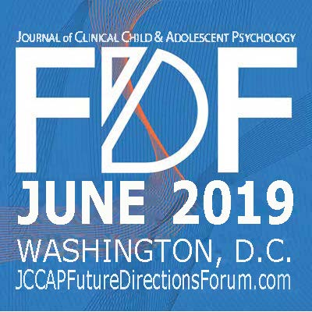

Suite Programs Thursday Aug 9
Marriott Marquis Suite # TBA

THURSDAY AUGUST 9th

1pm-2:30pm
Networking for International Students-Make the most of APA
APA is a huge convention, and attracts people interested in psychology from around the world. The size that makes it appealing also can be overwhelming. Come meet in an informal setting and share ideas about how to have the most fun and productive time now that you have come to convention!
Eric Youngstrom, PhD, Mian-Li Ong, MA, Yen-Ling Chen, MA

3:00pm-4:00pm
Open House-ALL SCCAP Members welcome!
Come relax and hangout in between sessions with other division member.
Sponsored by the SCCAP Membership Committee

4:00-4:50pm
Student Mentorship Program Meet-and-Greet/Q&A: The SCCAP Student Advisory Committee invites current members of the mentorship program (undergraduate students, graduate students, early career professionals) to join us for an informal meet-and-greet session. This session is also open to students and ECPs who are interested in learning more about the mentorship program, or who wish to join as a mentor/mentee! Applications to participate in the mentorship program will be available for attendees to complete during the event.

5:00-5:50pm
Student Advisory Committee Meeting: This is a closed committee meeting for current members of the SCCAP Student Advisory Committee.

6:00-6:50pm
SCCAP Social Hour – All SCCAP members are invited to attend.

Suite Programs Friday Aug 10

FRIDAY AUGUST 10TH

10:30am-Noon
HGAPS Wiki Instruction/Editing
Wikipedia is the sixth most visited site on the Internet. The combination of visibility, volume of users, ease of editing, speed of updating, and there being only one per language make Wikipedia and Wikiversity excellent for helping the best information about psychology reach the people who would benefit. Come learn about projects, and we’ll walk through making edits and implementing your suggestions.
Eric Youngstrom, PhD, Mian-Li Ong, MA, & HGAPS Team

Noon-12:50pm
Council of Specialties Meeting
Michael Roberts, PhD

1:00-3:00pm
Meet, Greet, and Get Published in Evidence-Based Practice in Child and Adolescent Mental Health!
Join our editorial team and board to learn about Division 53's clinical journal, and how you can become involved as a reviewer, board member, and get published. Editor Anne Marie Albano will be discussing the evolving journal and seeking volunteers to head up special series. Please join us!

3:00-3:50pm
Open House-ALL SCCAP Members welcome!
Come relax and hangout in between sessions with other division member.
Sponsored by the SCCAP Membership Committee

4:00-4:50pm
SCCAP Gender Variance SIG Meeting, Goal setting for the next year, All SIG members welcome
Marco Hidalgo, PhD Diane Chen PhD

Suite Programs Saturday Aug 11

SATURDAY AUGUST 11th

9:00am-9:50am
Multiculturalism and Media: Promoting Evidence-Based Children’s Mental Health
Come connect with Dr. Cindy Graham for a conversation on engaging with the media as a psychologist of color. This conversation hour will focus on tips for emerging professionals and promoting children’s mental health within a multicultural society.
Sponsored by the SCCAP Diversity Committee

10:00am-10:50am
Open House- All SCCAP Members Welcome!
Come relax and hangout in between sessions with other division member.

11:00am-11:50am
Interested in Board Certification (getting your ABPP/ABCCAP)? Come learn why it's a good idea and how to do it.
David Langer, PhD, ABPP; Wendy Ward, Ph.D., ABPP

Noon-1:45pm
Wikipedia is the sixth most visited site on the Internet. The combination of visibility, volume of users, ease of editing, speed of updating, and there being only one per language make Wikipedia and Wikiversity excellent for helping the best information about psychology reach the people who would benefit. Come learn about projects, and we’ll walk through making edits and implementing your suggestions.
Eric Youngstrom, PhD, Mian-Li Ong, MA, & HGAPS Team

2:00-2:50pm
Speed Mentoring: Undergraduate and graduate students are invited to participate in SCCAPs annual speed mentoring event! Students will meet individually or in small groups with members of the SCCAP executive board for a 5-10 minute discussion, and will have the opportunity to rotate through discussion with various mentors. Students can use their time to seek mentorship on a range of topics, such as getting in to graduate school, building a program of research, learning and practicing evidence-based treatment, navigating career options, work-life balance, and so many more. This event provides an incredible opportunity to learn directly from experts in the field of clinical child and adolescent psychology!
Sponsored by the SCCAP Student Advisory Committee

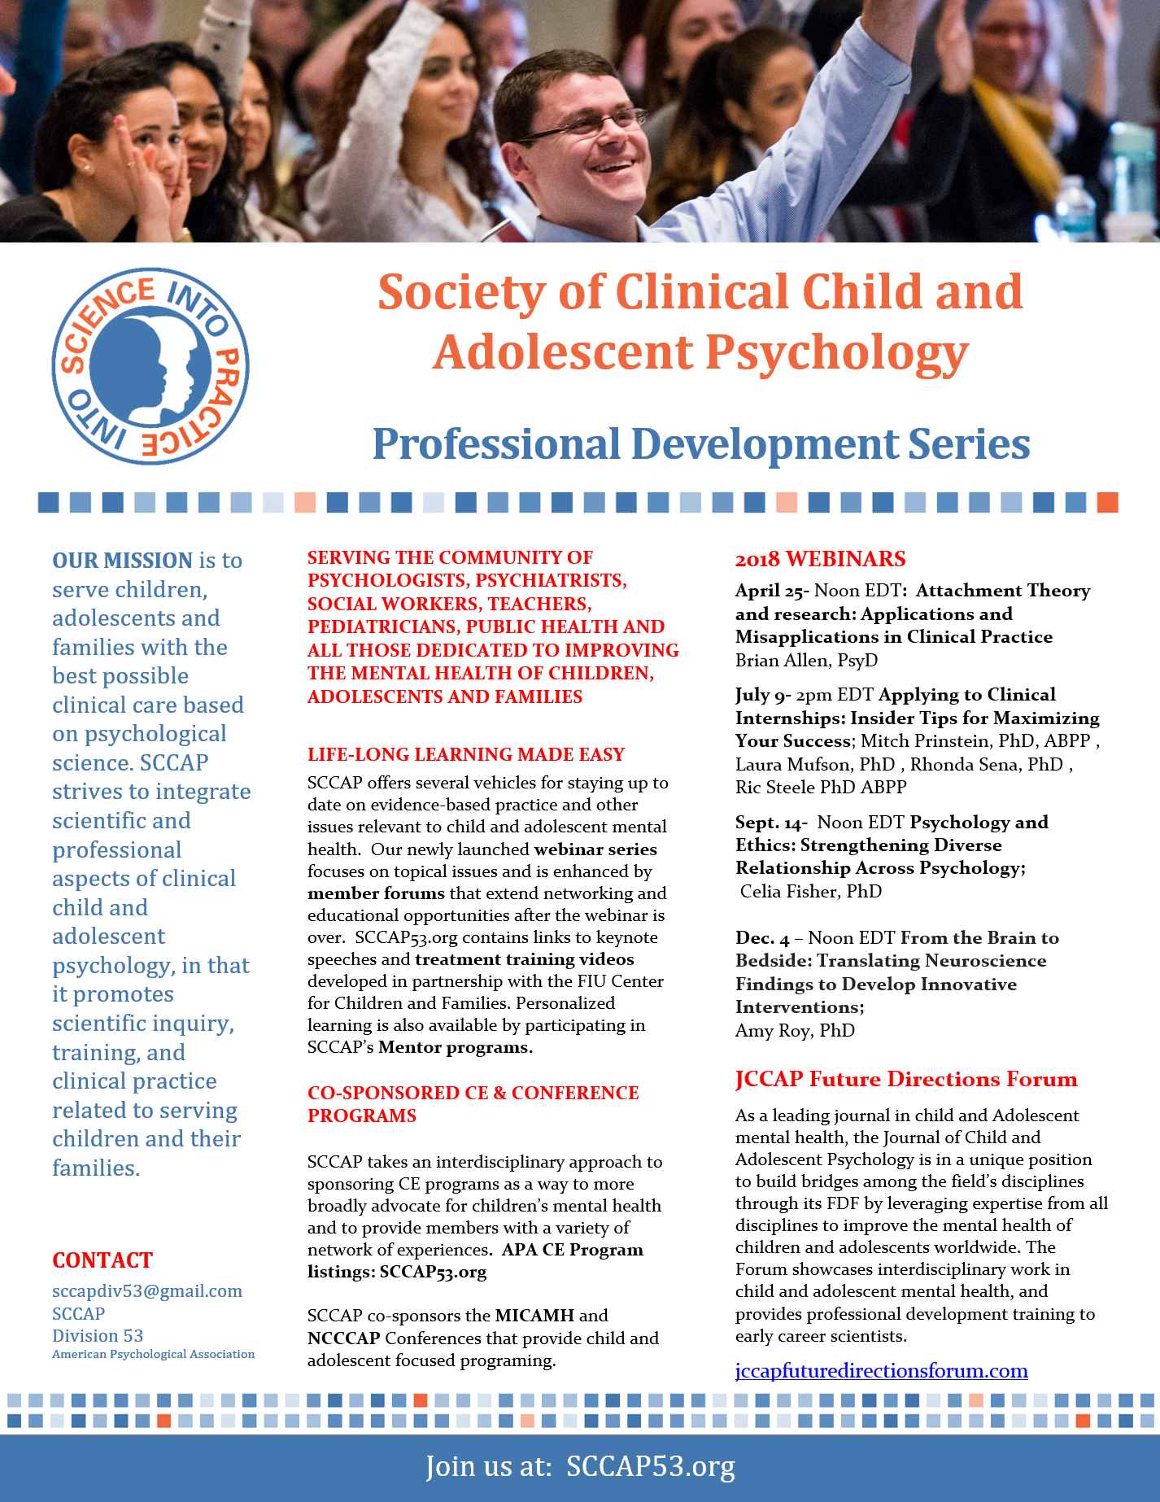
Professional Development Series

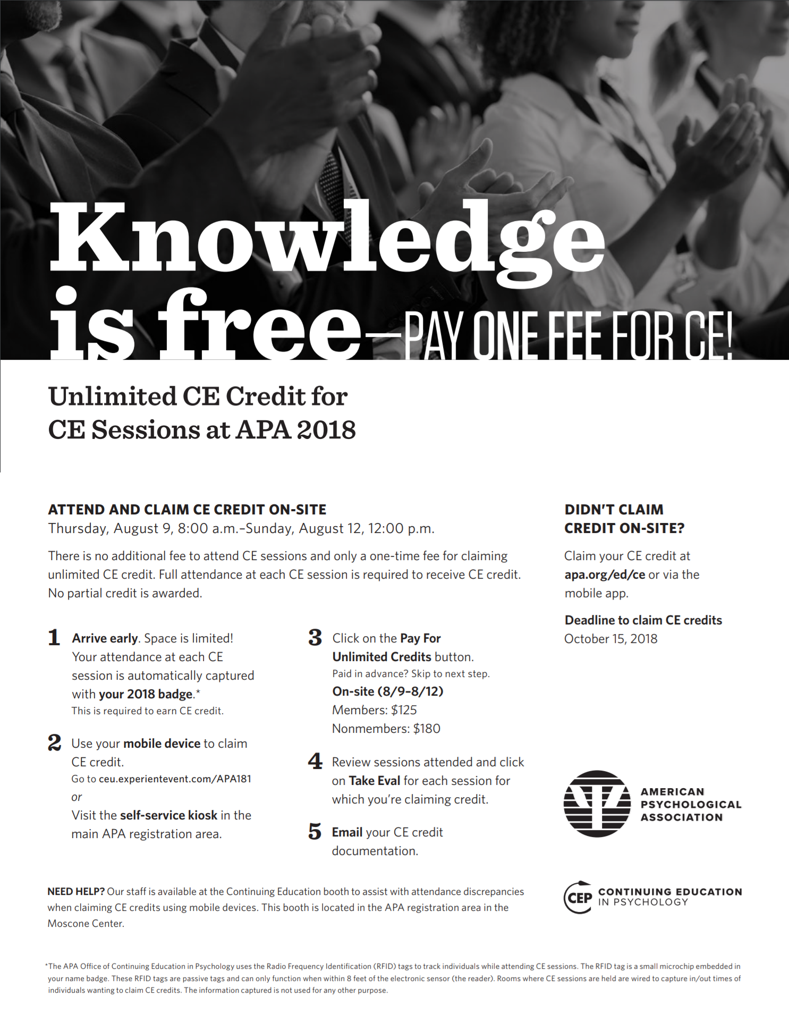
Unlimited CE Credit at APA 2018

Student Mentorship Flier
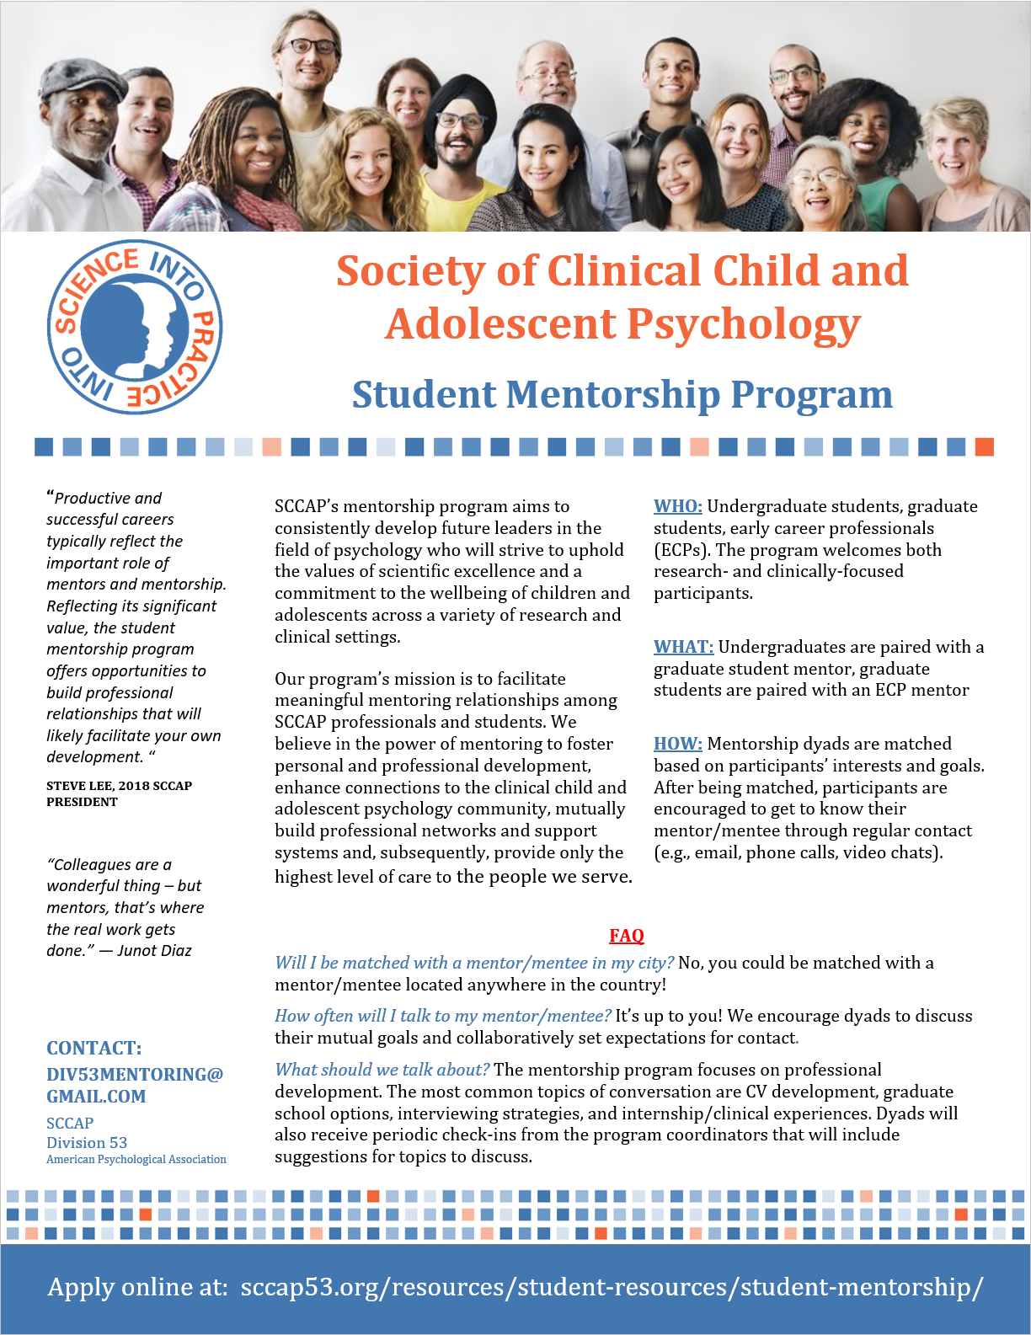

Join Us!
Join or renew your membership online at:
SCCAP53.ORG
Or use the supplemental mail-in form Members will receive an email with their website Username and Password. Members must log in to SCCAP53.org and complete their Member Profile. The website is the portal to many membership benefits such as online copies of the journals, member forum discussions and webinars.
Society Of Clinical Child And Adolescent Psychology
Division 53, American Psychological Association
Membership Application Form
Name ______________________________________________________________________________________________________________ | Listervs
Address ___________________________________________________________________________________________________________ | ⎕ Add me to the Division 53 listserv
City & State _______________________________________________________________________________________________________ | ⎕ Add me to the Division 53 listserv
Province & Country ______________________________________________________________________________________________ | ⎕ Add me to the Division 53 Student listserv
Zip or Postal Code ________________________________________________________________________________________________ | ⎕ Add me to the Division 53 Student listserv
Telephone _________________________________________________________________________________________________________ | ⎕ I wish to receive JCCAD & EPCAMH online only
E-mail address (Required) ______________________________________________________________________________________ | ⎕ I wish to receive JCCAD & EPCAMH online only
Membership Category (Check one box) | Rate
⎕ Full member of APA (not APA Student Affiliate or Foreign affiliate)  Please provide your APA ID Number. _______________________________________________________________ | $40.00
⎕ Associate member of APA,  Please provide your APA ID Number. _______________________________________________________________ | $40.00
⎕ Non-APA member or allied professional at or below the doctoral level | $40.00
⎕ Non-APA Associate member | $40.00
⎕ Student member of APA*  Please provide your APA Student Affiliate ID Number. ___________________________________________ | FREE
⎕ Student but not a student member of APA* | FREE
TOTAL DUES PAID IN U.S. FUNDS  (Please make checks or money orders payable to SCCAP) | $
Please return this form with payment to:
David Langer, Treasurer
SCCAP
c/o Lynn Canty, Director of Operations
PO Box 3372 Thank you for your support of SCCAP
Alpharetta, GA 30005

Celebrating our 2018 Award Winners
Please join us on Saturday August 11th as we honor the 2018 SCCAP Award Winners 4pm-6pm Moscone Center 2008.
Featuring SCCAP Distinguished Career Award Address: 37 Incredible Years: The Development and Innovation of the Incredible Years Programs: Where to go from here?
Carolyn Webster-Stratton, Ph.D. MSN, MPH
Award or Grant | Recipient | Institution
Abidin Early Career Award and Grant | Anna Van Meter Ph.D. | Northwell Health
Distinguished Career Award | Carolyn Webster-Stratton, PhD, MSN, MPH | University of Washington
Promoting Evidence-Based Mental Health Services for Children and Adolescents Award | MaryAnn McCabe, PhD,ABPP | George Washington University
Routh Research and Dissertation Grant | Jonathan Preszler | Washington State
Routh Research and Dissertation Grant | Salome Vanwoerden | University of Houston
Routh Research and Dissertation Grant | Amy Rapp | UCLA
Routh Research and Dissertation Grant | Lindsey Huffhines | Kansas University
Routh Research and Dissertation Grant | Sophie Foss | Long Island University
Routh Research and Dissertation Grant Honorable Mention | Vanessa Mora-Ringle | University of Miami
Routh Research and Dissertation Grant Honorable Mention | Fiona Macphee | Florida International University
Routh Research and Dissertation Grant Honorable Mention | Carolina Bejarano | Kansas University
Diversity Travel Awards | TBA
Student Poster Award at the MICAMH Conference | Rachel B. Tenenbaum | Florida International University
Student poster Award at the NCCCAP Conference | TBA
APA Student Awards | Yen-Ling Chen | University Nevada Las Vagas
APA Student Poster Award - Best Overall Post-Baccalaureate | Kristen O'Loughlin | Northwestern University
APA Student Poster Award - Diversity Research Graduate Student | Christina Lee | Indiana University
APA Student Poster Award- Best Overall Undergraduate | Akash Wasil, Katherine Venturo-Conerly | Harvard University
APA Student Poster Award - Translational Research | Tamara Humphrey (Post Doc) | University of Ottawa
APA Student Poster Award - Innovative Research Graduate | Sungha Kang | University of Massachusetts
APA Student Travel Award (see website for additional 2018 award opportunities) | Yen-Ling Chen | University Nevada Las Vegas
SAC Student Achievement Award - Undergraduate (1) | Isabel Ghisolfi | Columbia University
SAC Student Achievement Award Early-stage Graduate (1) | Carrie Jackson | West Virginia University
SAC Student Achievement Award - Late-stage Graduate (2) | Christine Wang | University of Maryland College Park
SAC Student Achievement Award - Late-stage Graduate (2) | Farzana Saleem | George Washington University
Graduate Student Achievement Award in Clinical Practice (1) | Christina Sharkey | Oklahoma State
Initial APA Fellow | Martha C. Tompson PhD | Boston University
SCCAP Fellows | Daniel M Bagner, PhD, ABPP | Florida International University
 | Sharon Berry, PhD ABPP | Children's Minnesota
 | Jonathan S Comer, Ph.D | Florida International University
 | Wendy M Reinke, PhD | University of Missouri

Thank You to Our Award Reviewers

Thank you to the community of dedicated volunteers that took the time to review applications for the SCCAP Awards Program. Through your efforts SCCAP was able to incentivize members that are dedicated to the science and practice of advancing good mental health for children and adolescents.

Brian Allen, Psy.D.
Marc Atkins, PhD
Sunny Bai, PhD, MPH
Dan Bagner, PhD, ABPP
Ted Beauchaine, PhD
Ed Christophersen, PhD, ABPP
Jon Comer, PhD
Paula Fite, PhD
Devon Gangi, PhD
Steve Hinshaw,PhD
Jessica Jenness, PhD
Shawn Jones, PhD
Katharina Kircanski, PhD
Amy Krain Roy, PhD
Tony Spirito, PhD
Josh Langberg, PhD
Eli Lebowitz, PhD
Adam Lewin, PhD, ABPP
Jean Mercer, PhD
Erica Musser, PhD
John Piacentini, PhD, ABPP
Anne Pidano, PhD
Vanessa Reinhardt, PhD
Emily Ricketts, PhD
Vanesa Ringle, PhD
Michelle Rozenman, PhD
Leigh Spivey, MA
Andrea Young Ryan, PhD
Anna Van Meter, PhD
Andres Viana, PhD

